**NATIONAL INSTITUTE OF TECHNOLOGY**

**TIRUCHIRAPPALLI**

Department of Computer Application

***CRICKET SCORESHEET MANAGEMEN SYSTEM***

**Project Work**

Submitted By :

1. **SANJAY KUMAR- 205119091**
2. **UTSAV OJHA - 205119107**

Under the Guidance of

**Dr. P. Chitra**

**INDEX**

|  |  |  |
| --- | --- | --- |
| S.No. | Discription | Page No. |
| 1. | INTRODUCTION | 3 |
| 2. | ABSTRACT | 3 |
| 3. | SYSTEM CONFIGURATION | 4 |
| 4. | SYSTEM MODULE | 5 |
| 5. | IMAGE | 7 |
| 6. | FUTURE ENHANCEMENT | 10 |
| 7. | CONCLUSION | 10 |
|  |  |  |

**1.Introduction**

Cricket score book is a easy to handle the score information .IT is the quickest, easiest and most comprehensive method of cricket scoring . IT has been designed to cater for the needs of both novice and experienced scores.

By utilisizing the flexibility and ease of use of the Microsoft window environment the window cricket Scorebook provides

**2. Abstract:**

We can store the scores by using score book for all matches. This cricket score sheet book has many details of play from batsman runs to bowler starts. This book is designed to include every minute start of the match.

**3. System Configuration**

**Hardware:-**

Processor : Intel Prntium 4

RAM: 512 Mb

Hard Disk: 80 GB HD

Keyboard: 104 keys

Mouse: Logitech Mouse

Display type: VGA

**Software requirements:-**

Operating system:- Window 7,8,10

Programming language: c++

Backend : WordPad

**4. System Modules**

**Functions Used:**

The C source code of this project is very simple and consists of seven user defined functions. They are listed below along with the tasks they perform.

* **void date()** –  to store current date or date of game.
* **void printt()** – to print the output in specific format.
* **void filewrite()** – to write in  a file on hard drive of computer to store the input data such as runs, wickets, balls, over etc.
* **void fileread()** – to extract or read the data from the file created to store the data.
* **void fileopen(char)** – opens a cricket score sheet project file from the computer.
* **int limitedinput(int)** – to input some limited data.
* **void newscoresheet()** – to create new score sheet in a new file.

When the project file of cricket score sheet project is executed, it works by following the steps described below:

* First of all the project displays the welcome screen and the screen fades up to display the main menu.
* The main menu comprises three options namely:  
  -> New Score Sheet  
  -> View Score Sheet  
  -> Exit
* If ‘1’ is entered, Cricket Score Sheet project asks for the name of new score sheet. When the file is created, a message is displayed on the screen.
* Then, the score sheet appears on screen in which the user has to input the following information:

1. Competition
2. Venue
3. Match between and versus
4. Toss winner team
5. Elected choice of toss winner
6. Inning and date
7. Name of batsman and run hit by each of them
8. Name of bowler and run given by each blower

* After inputting these data, the program asks user to input ‘e’ to edit the data and ‘c’ to continue.
* If the user inputs ‘2’ in the main menu, the program asks for the name of file. If the file is found, it is displayed. Otherwise, error message is printed on the screen.
* The third option in main menu is exit. If ‘3’ is entered in the main menu, the Cricket Score Sheet project terminates.

**5. IMAGE**

* + 1. **LOGIN PAGE:**

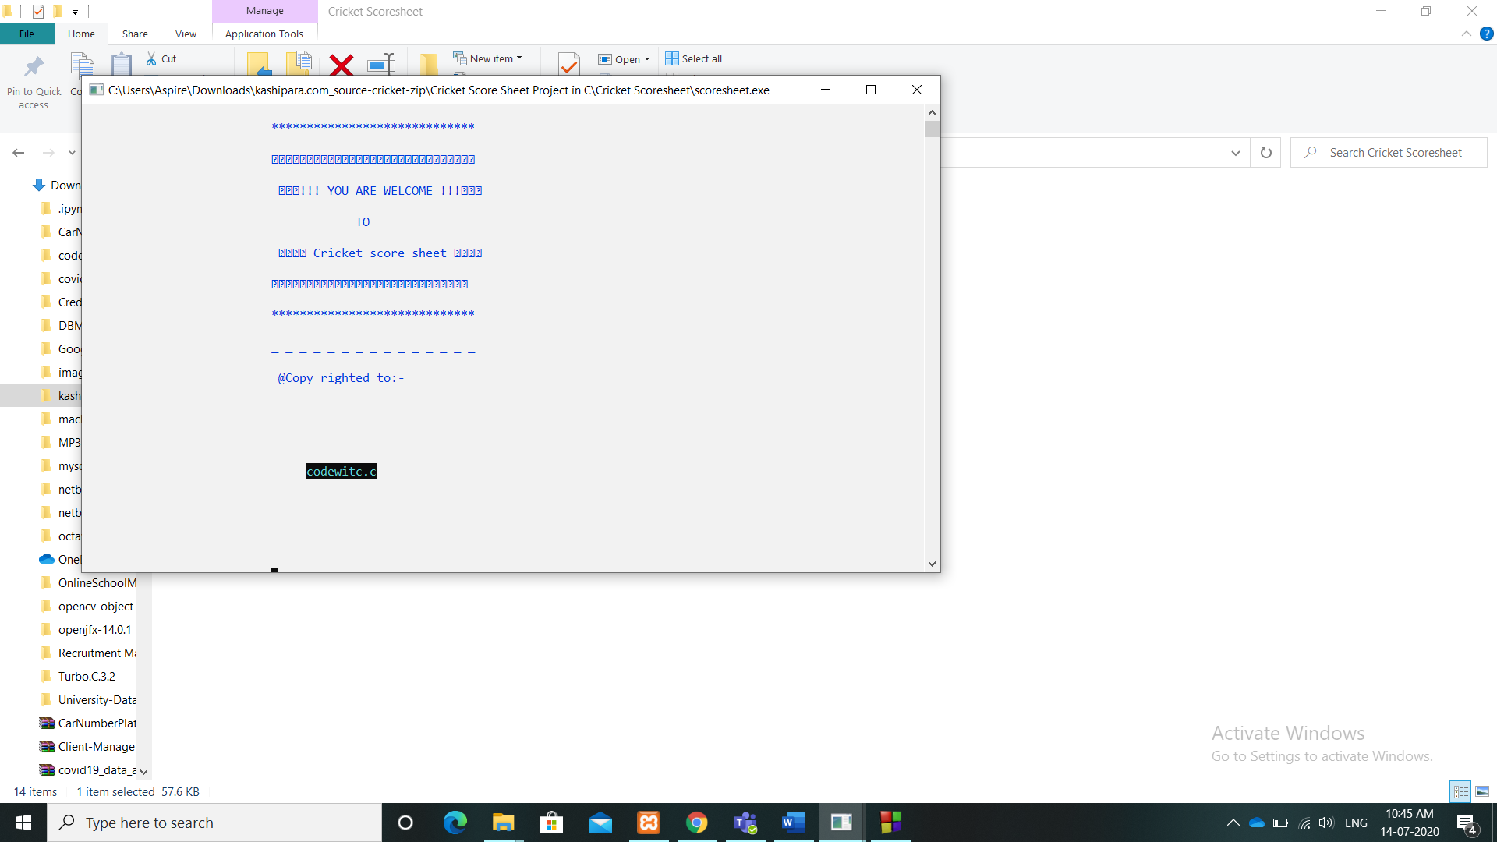

**2. MENU:**

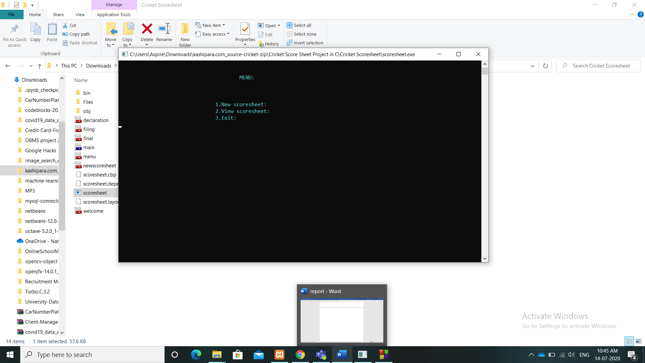

**3. New Scoresheet:**

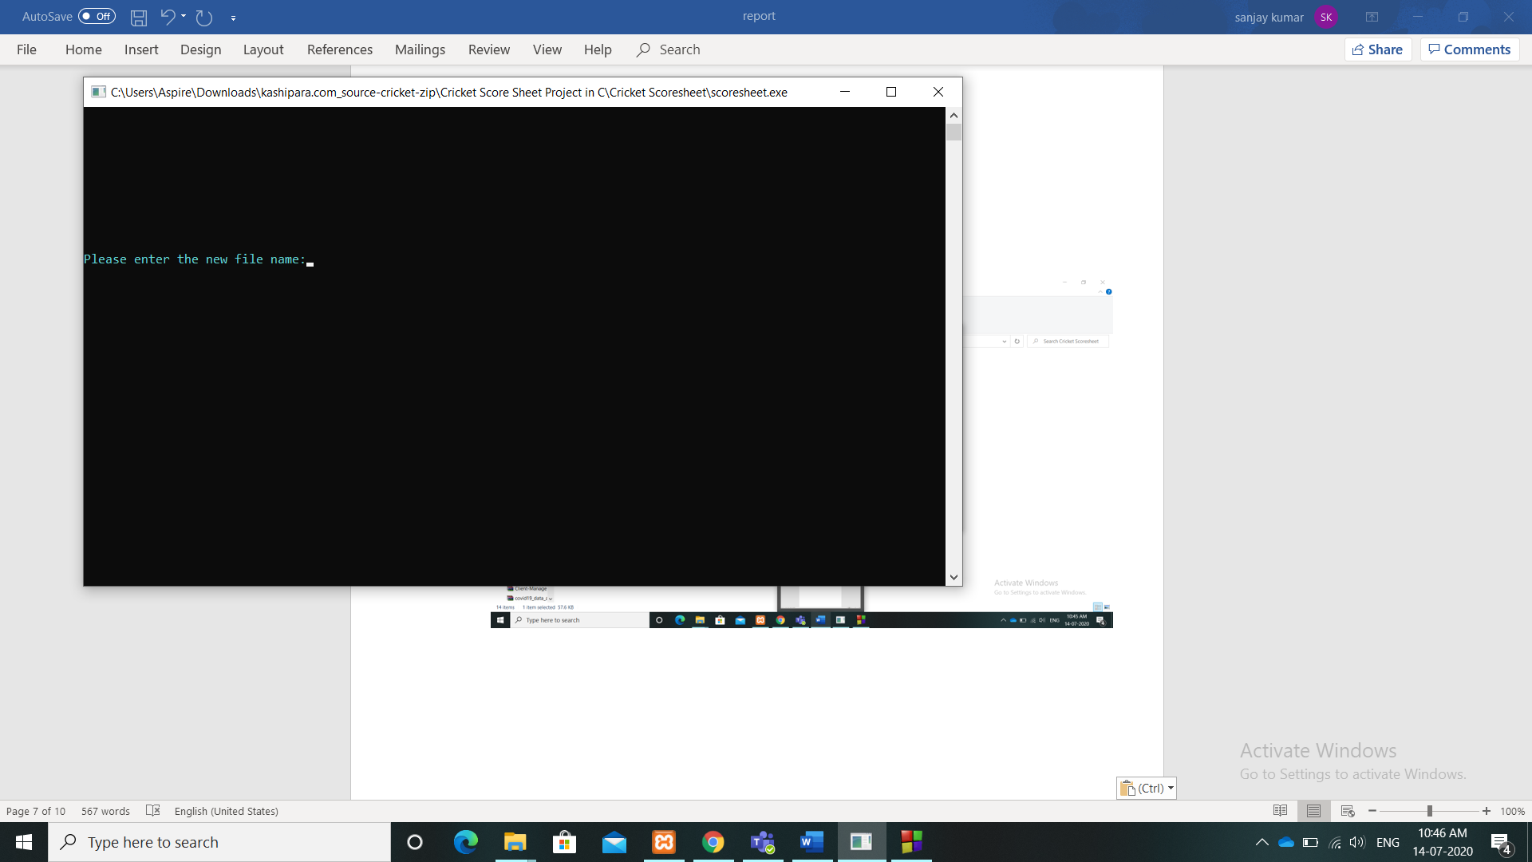

**4. CREATE New ScoreSheet:**

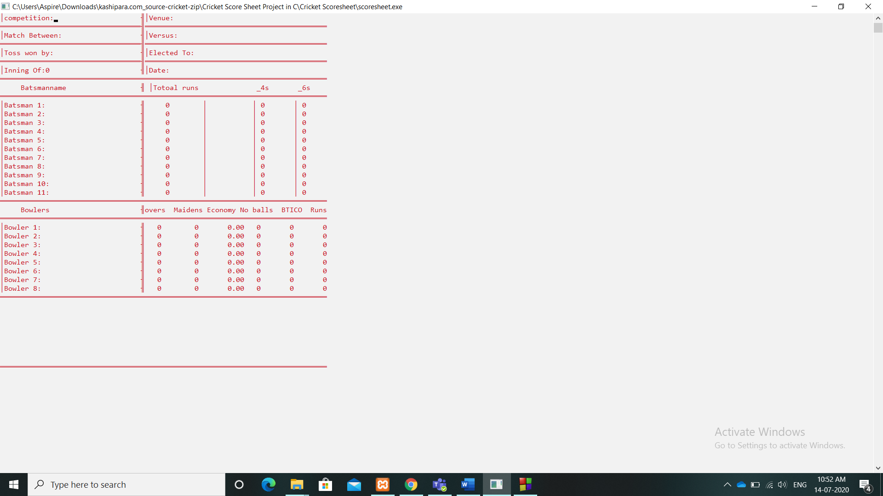

**5. Open Existing Scoresheet:**

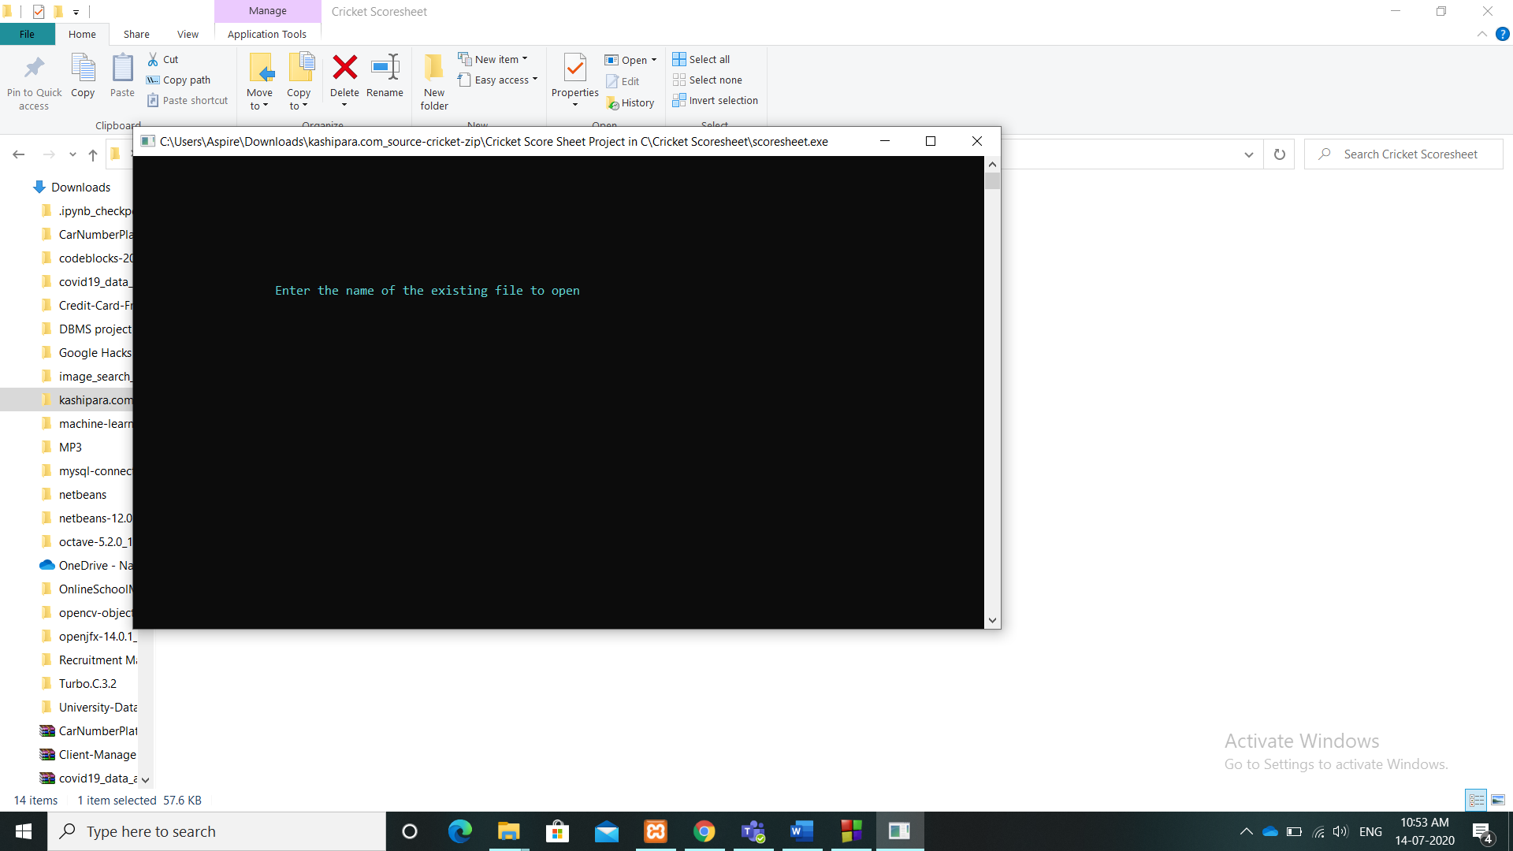

**6. Open Existing Scoresheet:**

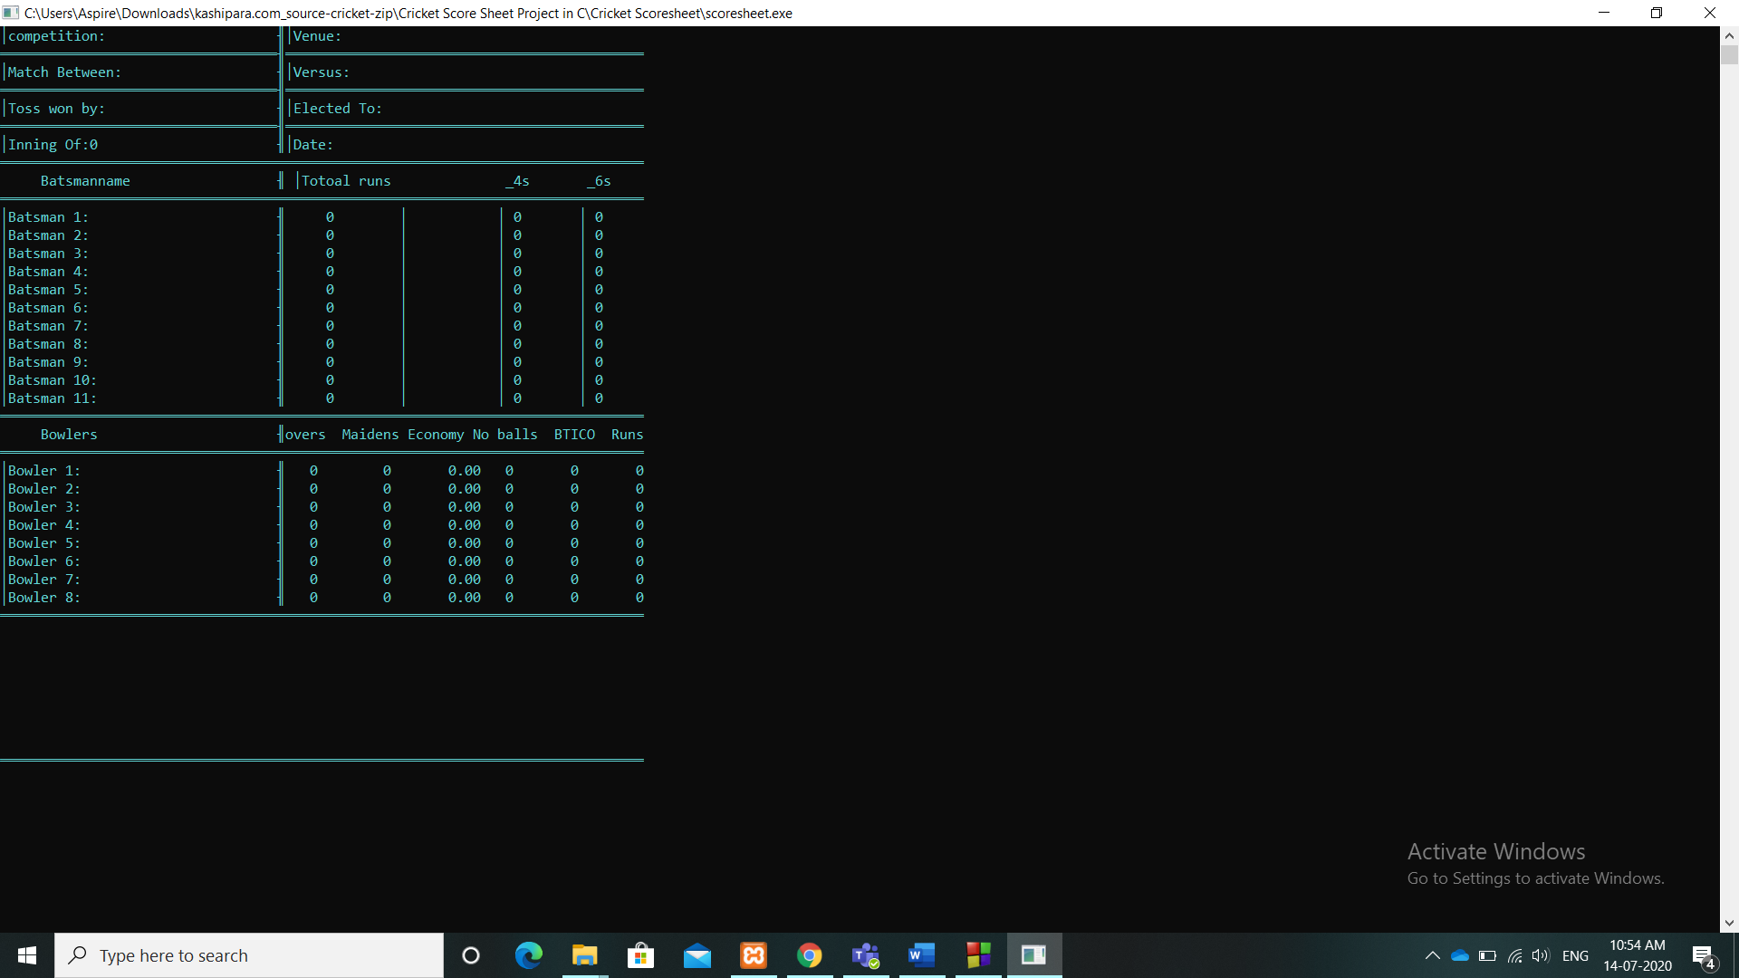

**6. Future enhancement**

I will develop my project to add the new information. I will make my score sheet colorfully. I will insert a new tools.

**Next Version:-**

1. Automatically to store the score
2. Display the Batsman details orderly
3. Patership
4. Come to like a 3D effect.

**7. Conclusion:**

The Application developed is designed in such a way that any further enhancement can be done with ease. The system has the capabalities for easy intregration with other ststems. New modules can be added to the exiting system with less effort.